*Florida International University*

*School of Computing and Information Sciences*

Software Engineering Focus

Feature Document

User Story ID #788 Using WebVR API for

Selection Sort

**Name: Daniel Khawand**

**Team Member(s):** Pachev Joseph, Hamilton Chevez, Bernardo Pla, Daniel Rivero

**Project: WebVR 1.0**

**Product Owner(s)**: Francisco Ortega

**Mentor(s)**: Francisco Ortega

**Instructor**: Masoud Sadjadi

**User Story Name:**

* As a user, I want to observe a selection sort on a web page with a VR environment so that I can understand the algorithm better.

Acceptance Criteria

* User can go into VR mode
* Each iteration of the selection sort is clearly illustrated

**Use Case**

* Name: View Selection Sort
* Actor: User
* Preconditions: Webpage accessed, WebGL enabled, and VR is enabled
* Description:
* User watches Selection Sort iteration by iteration

**Use Case Diagram**

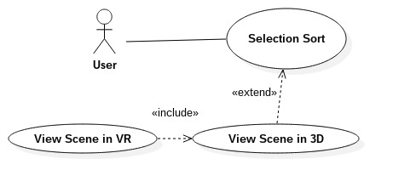

**Sequence Diagram**

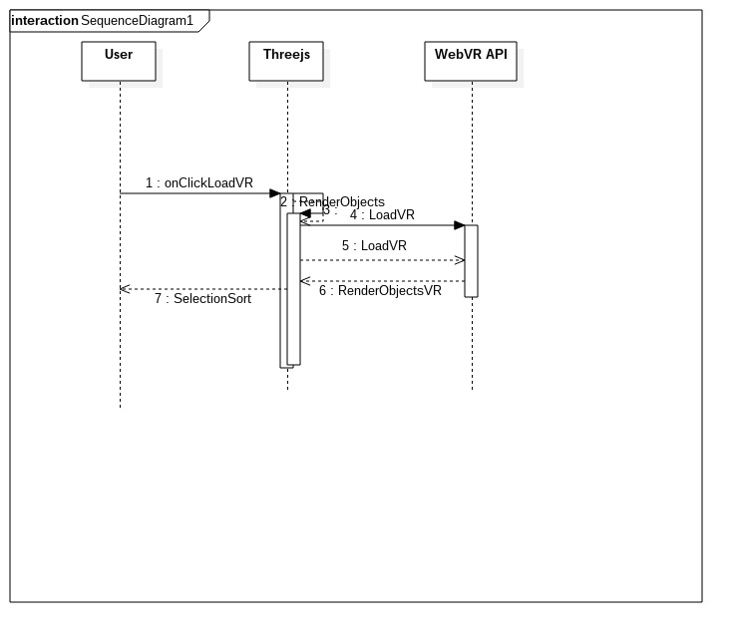

**Class Diagram**

**Unit Test**

* Test case ID:
* Description/Summary of Test:
* Pre-condition:
* Expected Results:
* Actual Result:
* Status (Fail/Pass):

**Integration Test**

**Visual User Guide**

**Iteration of sorting below**

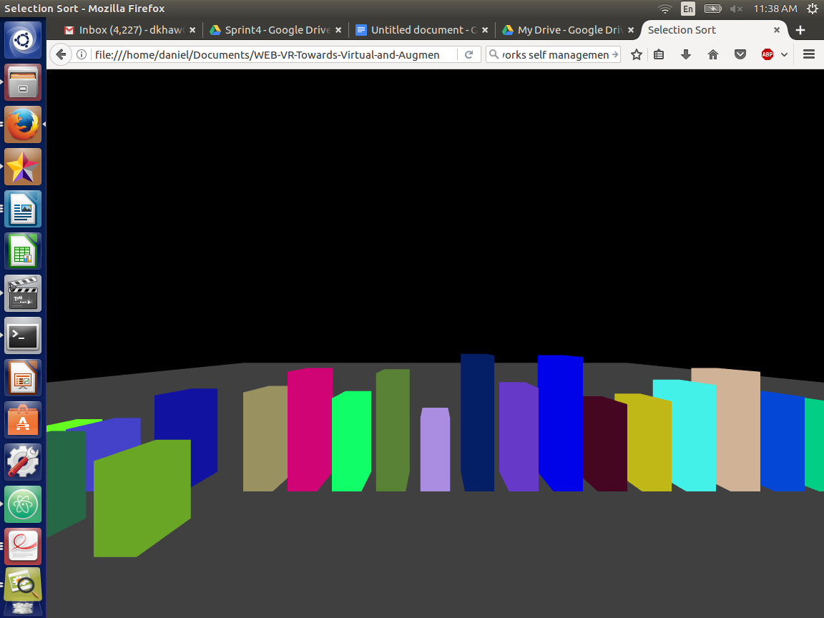

**Sort complete below**

